5.1 Vector Field Worksheet

- Sketch the vector field .

- Let . Sketch the vector field

- Sketch the vector field .

- Compute the gradient vector field of f, where

- Three vector fields are shown below. Which of the vector field corresponds to ?
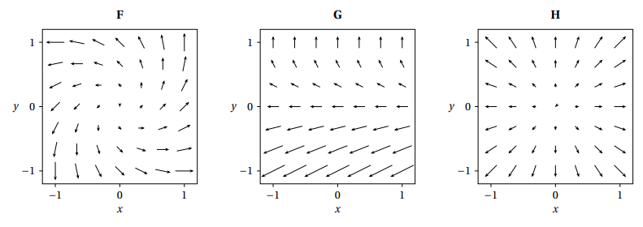

- Here are plots of 6 vectors fields on the box where , , and . Which of the following vector fields corresponds to the vector field ?
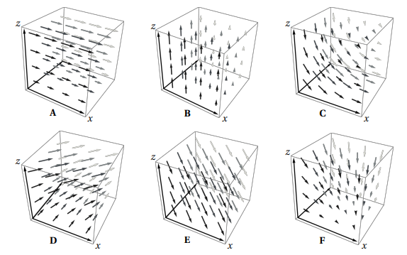

- Here are plots of 5 vectors fields on the box where , , and . Which of the following vector fields corresponds to the vector field ?
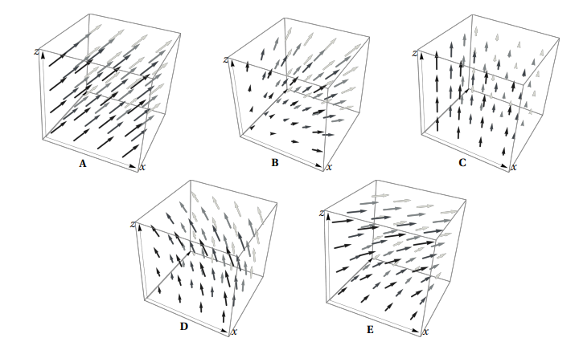

- Determine if the vector field is conservative.

- Determine a potential function for the vector field .

